Patrick Richard

Client Documentation

The problem that I am trying to address is my Great Uncle is trying to get a business up and running and he needed a website to be built. He had someone start to design a website but he didn’t ever really get around to finishing it. You can actually view the website at [www.marchwick.com](http://www.marchwick.com). As you can see, the website is outdated. This looks like a website you may have seen 5+ years ago. I offered to fix his site up for him and make it look up to date. Below is a sketch of my ideas for this webpage.

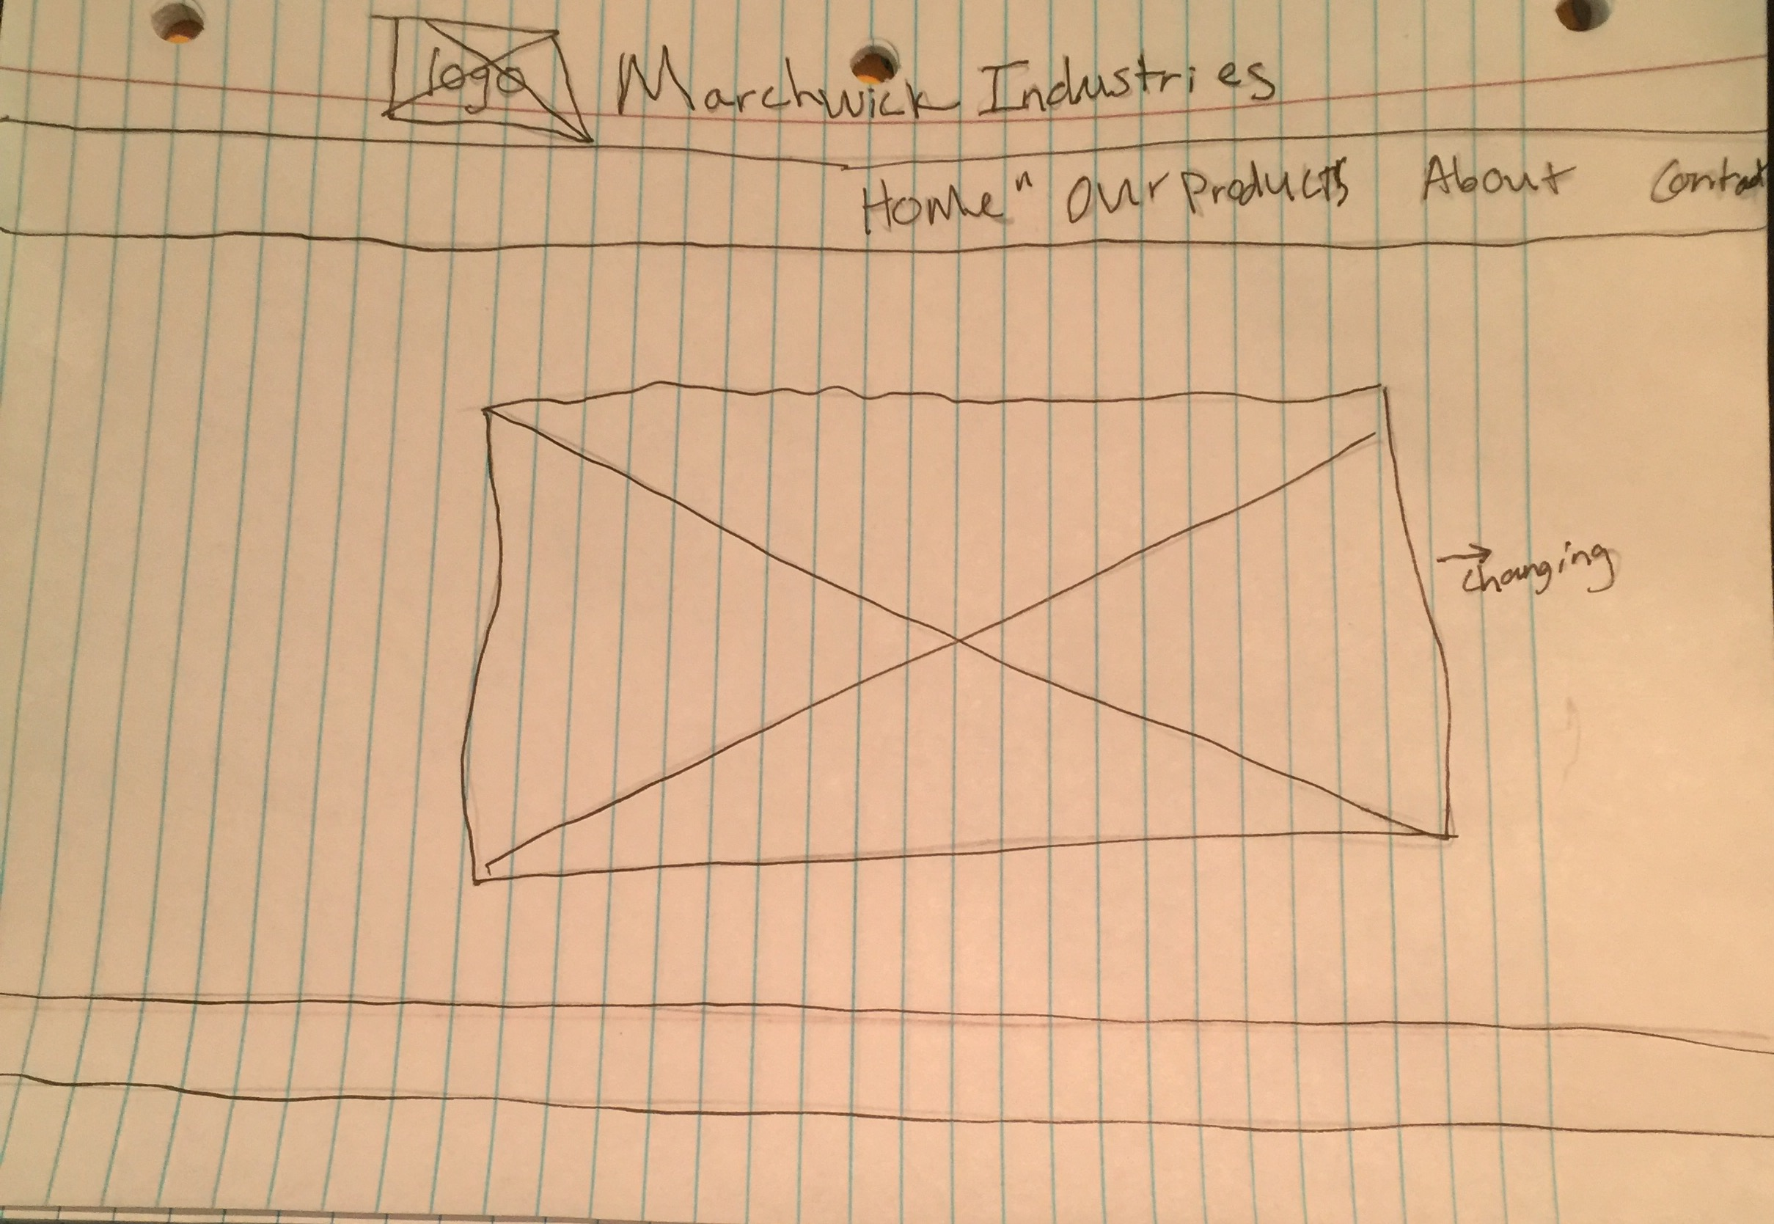

A lot of the things that I have been reading in the Redish text remind me of a class I took here at the U which was Visual Rhetoric and Document Design. The thing that stood out to me the most and made the most sense from my personal point of view was the amount of content to include on the home page. The heading that says it all in the Redish text is, “Home pages – content-rich with few words.” You do not want to scare people away by having large blocks of text on the page. People want to scan and get information. I tried to do this by eliminating unnecessary text on the page. I made a navigation bar with four main categories. I also tried to have the main focus of the homepage be some of the products that you will find in the webpage. Very simple, and clean design makes it appealing to the eye and does not scare people away at first glance.